**COMPUTER SCIENCE DEPARTMENT**

Computer Organization and Assembly Language

**Lab Task # 10**

**Last date of Submission: 19th May 2024**

# Submitted To: Sir Ahmed Saleem

**Student Name: UBAID-BIN-WARIS**

# Reg. Number: 2212416

# 

**Question no. 01**

A sample program titled centered text is provided. The program displays some text in the center of the display screen. Modify the code to display the text in the four corners of the screen.

**Code**

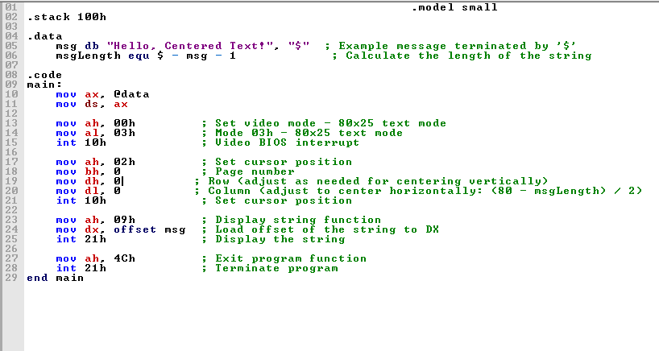



**Output**

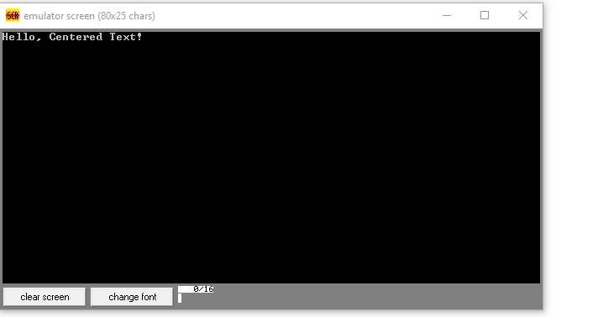

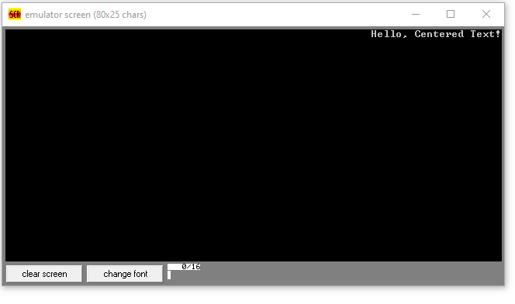

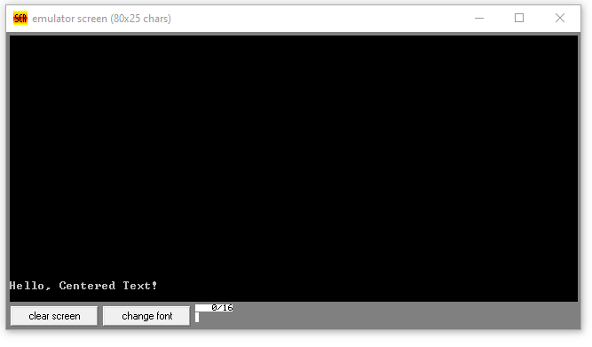

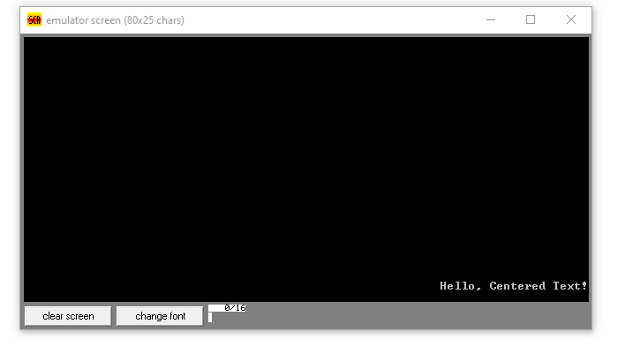

**Question no. 02**

 Another program titled name with changing background is also provided which displays a name/text with different color and background. Each character of the text is displayed for a short time and then displaced by the next character. Modify that to display the complete text in a linear fashion so that the complete text is shown. Note: this will need a counter/comparison etc.

**Code**

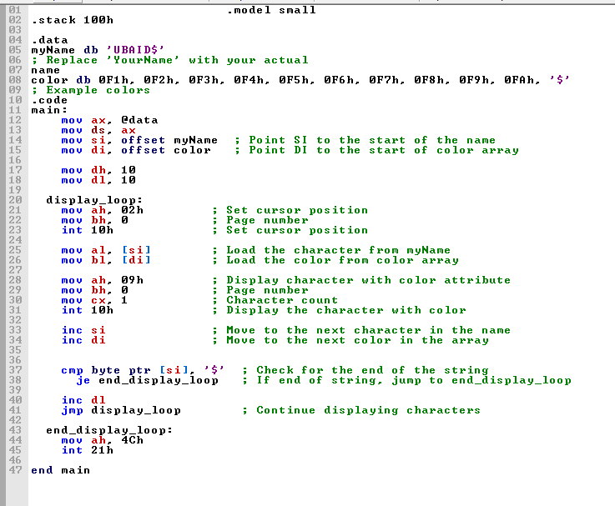

**Output**

